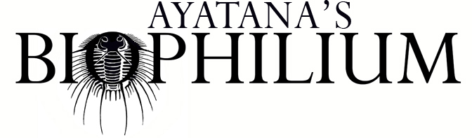
This form is for alumni who would like to return with a collaborator and take advantage of the 2 for 1 bring-a-friend deal.

Which residency are you applying for?
If you are interested in more than one, please indicate your preference.

Online 2026:
☐ Bird Nerds: Ornithology for artists -May
☐ Germinate: Botany for artists -June
☐ Locomotion: Autonomy and navigation in biology - July
☐ Rewild: Habitat Conservation and ecological restoration -August
☐ Mycophilia: Mushrooms and fungi for artists -September
☐ Mortem: Death school for artists -November
Online 2027:
☐ Ritual: Ceremonial Magic for Artists
☐ Sweet Nothing: Mating styles and life cycles
☐ Swamps: Wetland wildlife and eco-mythology
☐ Ecofeminism: Gender and the wild
☐ Would you attend more than one of the programs you chose?

Returning Artist Name:
Returning Artist year and/or program of participation:
Collaborator’s Name:

Collaborator’s City of residence:

Collaborator’s Email address:

Collaborator’s Website and/or social media:

If you participate, can we post your artist statements and an image on our website?

Is there something specific you are studying (a species or concept for example) that we can include in the program to make the residency more useful for your practice?

